**Hello World RESTful Web Service   
  
Write a REST service in the spring learn application created earlier, that returns the text "Hello World!!" using Spring Web Framework. Refer details below:  
  
SOLUTION:**

**HelloController.java:**

package com.cognizant.springlearn.controller;

import org.slf4j.Logger;

import org.slf4j.LoggerFactory;

import org.springframework.web.bind.annotation.GetMapping;

import org.springframework.web.bind.annotation.RestController;

@RestController

public class HelloController {

private static final Logger LOGGER = LoggerFactory.getLogger(HelloController.class);

@GetMapping("/hello")

public String sayHello() {

LOGGER.info("START - sayHello()");

String response = "Hello World!!";

LOGGER.info("END - sayHello()");

return response;

}

}  
  
**SpringLearnApplication.java:**

package com.example.springlearn;

import java.util.Collections;

import org.slf4j.Logger;

import org.slf4j.LoggerFactory;

import org.springframework.boot.SpringApplication;

import org.springframework.boot.autoconfigure.SpringBootApplication;

@SpringBootApplication

public class SpringLearnApplication {

private static final Logger LOGGER = LoggerFactory.getLogger(SpringLearnApplication.class);

public static void main(String[] args) {

LOGGER.info("START - main() method");

SpringApplication app = new SpringApplication(SpringLearnApplication.class);

app.setDefaultProperties(Collections.singletonMap("server.port", "8083"));

app.run(args);

LOGGER.info("END - main() method");

}

}

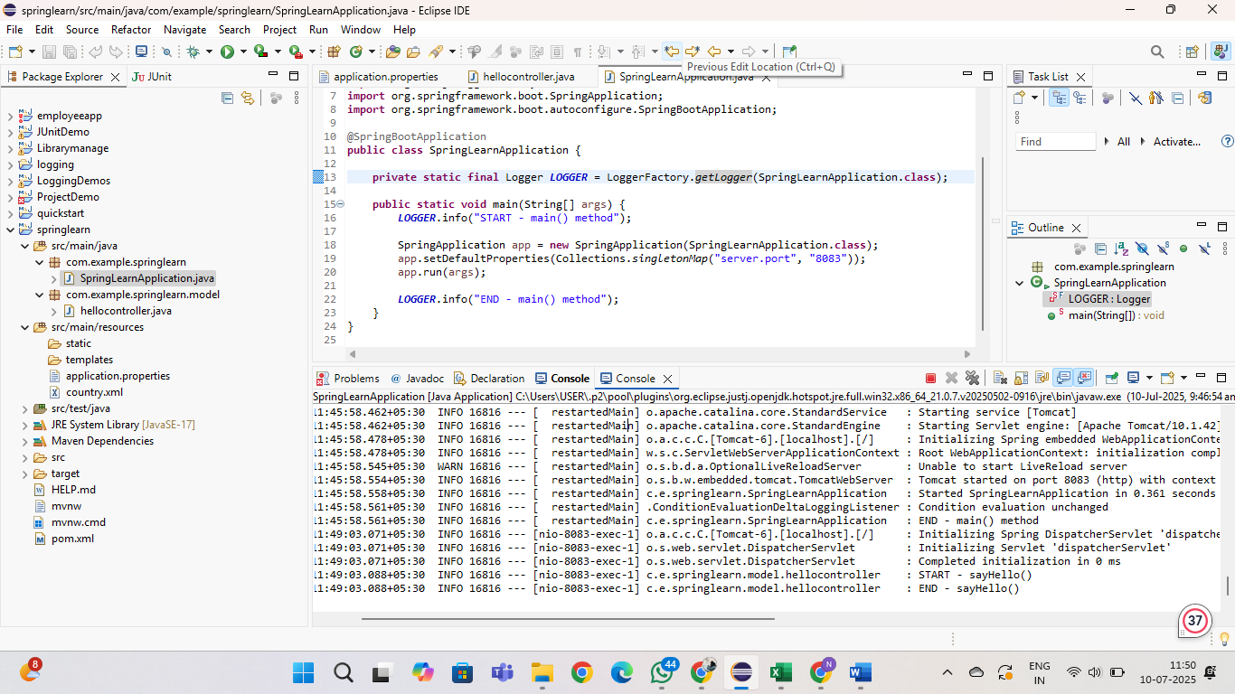

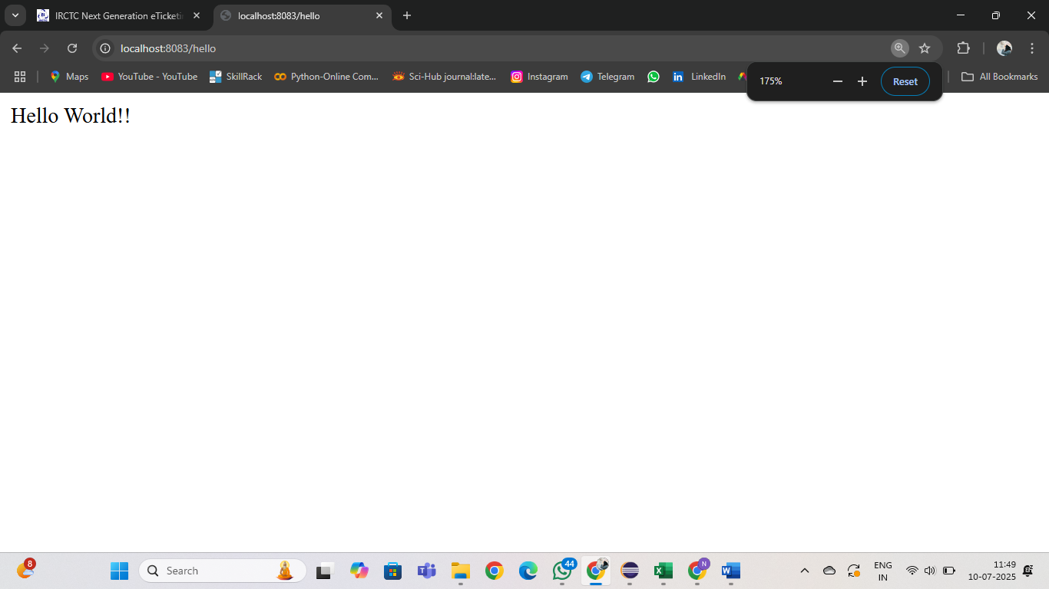

**REST - Country Web Service   
  
Write a REST service that returns India country details in the earlier created spring learn application.**

**SOLUTION:**

**SpringApplication.java:**

**package** com.example.springlearn;

**import** java.util.Collections;

**import** org.slf4j.Logger;

**import** org.slf4j.LoggerFactory;

**import** org.springframework.boot.SpringApplication;

**import** org.springframework.boot.autoconfigure.SpringBootApplication;

@SpringBootApplication

**public** **class** SpringLearnApplication {

**private** **static** **final** Logger ***LOGGER*** = LoggerFactory.*getLogger*(SpringLearnApplication.**class**);

**public** **static** **void** main(String[] args) {

***LOGGER***.info("START - main() method");

SpringApplication app = **new** SpringApplication(SpringLearnApplication.**class**);

app.setDefaultProperties(Collections.*singletonMap*("server.port", "8083"));

app.run(args);

***LOGGER***.info("END - main() method");

}

}

**Country.java:**  
  
**package** com.example.springlearn.model.country;

**public** **class** country {

**private** String code;

**private** String name;

**public** country() {

System.***out***.println("Inside Country Constructor.");

}

**public** String getCode() {

System.***out***.println("Getter for code called");

**return** code;

}

**public** **void** setCode(String code) {

System.***out***.println("Setter for code called");

**this**.code = code;

}

**public** String getName() {

System.***out***.println("Getter for name called");

**return** name;

}

**public** **void** setName(String name) {

System.***out***.println("Setter for name called");

**this**.name = name;

}

@Override

**public** String toString() {

**return** "Country [code=" + code + ", name=" + name + "]";

}

}

**Controller.java:**  
  
**package** com.example.springlearn.model;

**import** org.slf4j.Logger;

**import** org.slf4j.LoggerFactory;

**import** org.springframework.context.ApplicationContext;

**import** org.springframework.context.support.ClassPathXmlApplicationContext;

**import** org.springframework.web.bind.annotation.RequestMapping;

**import** org.springframework.web.bind.annotation.RestController;

**import** com.example.springlearn.model.country.country;

@RestController

**public** **class** controller {

**private** **static** **final** Logger ***LOGGER*** = LoggerFactory.*getLogger*(controller.**class**);

@RequestMapping("/country")

**public** country getCountryIndia() {

***LOGGER***.info("START - getCountryIndia()");

ApplicationContext context = **new** ClassPathXmlApplicationContext("country.xml");

country contry = context.getBean("country", country.**class**);

***LOGGER***.debug("Country: {}", contry.toString());

***LOGGER***.info("END - getCountryIndia()");

**return** contry;

}

}

**OUTPUT:**

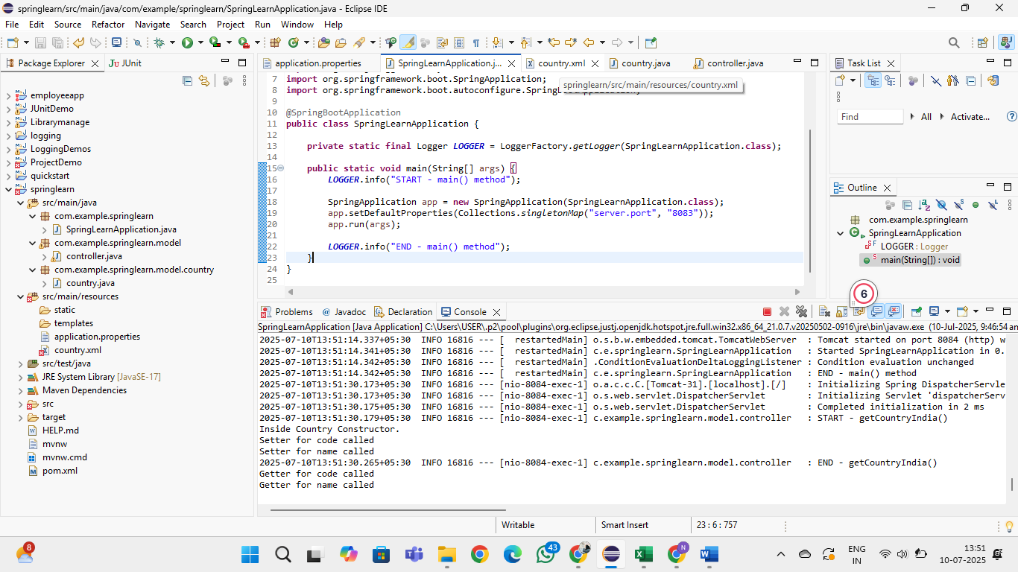

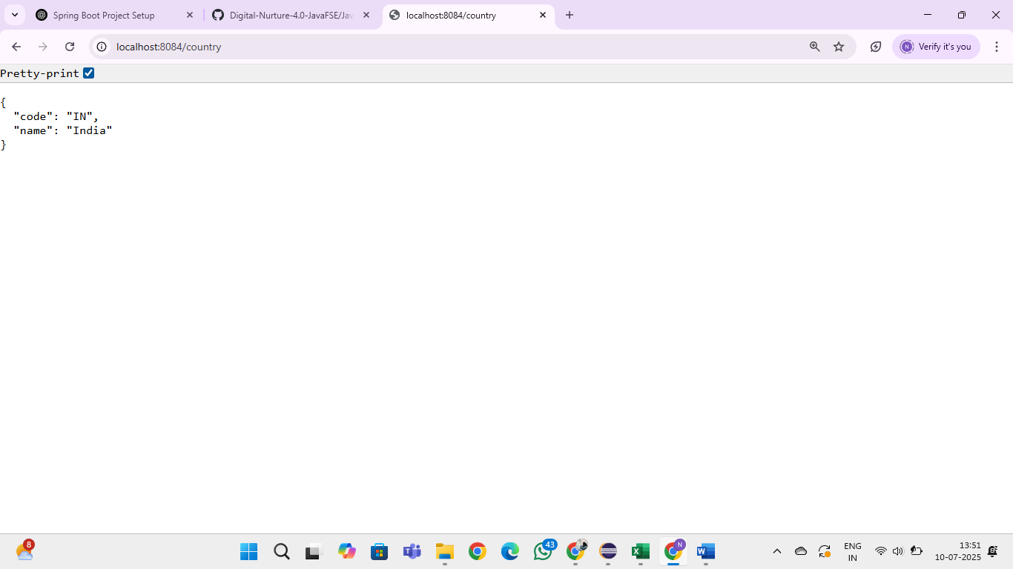

**REST - Get country based on country code   
  
Write a REST service that returns a specific country based on country code. The country code should be case insensitive.**

**SOLUTION:**

**SpringLearnApplication.java:**  
  
package com.example.springlearn;

import org.slf4j.Logger;

import org.slf4j.LoggerFactory;

import org.springframework.boot.SpringApplication;

import org.springframework.boot.autoconfigure.SpringBootApplication;

@SpringBootApplication

public class SpringLearnApplication {

private static final Logger LOGGER = LoggerFactory.getLogger(SpringLearnApplication.class);

public static void main(String[] args) {

LOGGER.info("START - main() method");

SpringApplication.run(SpringLearnApplication.class, args);

LOGGER.info("END - main() method");

}

}

**Country.java:**

package com.example.springlearn.model;

import org.slf4j.Logger;

import org.slf4j.LoggerFactory;

public class Country {

private static final Logger LOGGER = LoggerFactory.getLogger(Country.class);

private String code;

private String name;

public Country() {

LOGGER.debug("Inside Country Constructor.");

}

public String getCode() {

LOGGER.debug("Inside getCode()");

return code;

}

public void setCode(String code) {

LOGGER.debug("Inside setCode()");

this.code = code;

}

public String getName() {

LOGGER.debug("Inside getName()");

return name;

}

public void setName(String name) {

LOGGER.debug("Inside setName()");

this.name = name;

}

@Override

public String toString() {

return "Country [code=" + code + ", name=" + name + "]";

}

}  
  
**Country.xml:**

<?xml version="1.0" encoding="UTF-8"?>

<beans xmlns="http://www.springframework.org/schema/beans"

xmlns:xsi="http://www.w3.org/2001/XMLSchema-instance"

xsi:schemaLocation="http://www.springframework.org/schema/beans

https://www.springframework.org/schema/beans/spring-beans.xsd">

<bean id="country" class="com.example.springlearn.model.Country">

<property name="code" value="IN" />

<property name="name" value="India" />

</bean>

<bean id="countryList" class="java.util.ArrayList">

<constructor-arg>

<list>

<bean class="com.example.springlearn.model.Country">

<property name="code" value="IN"/>

<property name="name" value="India"/>

</bean>

<bean class="com.example.springlearn.model.Country">

<property name="code" value="US"/>

<property name="name" value="United States"/>

</bean>

<bean class="com.example.springlearn.model.Country">

<property name="code" value="DE"/>

<property name="name" value="Germany"/>

</bean>

<bean class="com.example.springlearn.model.Country">

<property name="code" value="JP"/>

<property name="name" value="Japan"/>

</bean>

</list>

</constructor-arg>

</bean>

</beans>  
  
**CountryService.java:**

package com.example.springlearn.service;

import com.example.springlearn.model.Country;

import org.springframework.context.ApplicationContext;

import org.springframework.context.support.ClassPathXmlApplicationContext;

import org.springframework.stereotype.Service;

import java.util.List;

@Service

public class CountryService {

public Country getCountry(String code) {

ApplicationContext context = new ClassPathXmlApplicationContext("country.xml");

List<Country> countries = (List<Country>) context.getBean("countryList");

return countries.stream()

.filter(c -> c.getCode().equalsIgnoreCase(code))

.findFirst()

.orElse(null);

}

}  
  
**CountryController.java:**

package com.example.springlearn.controller;

import com.example.springlearn.model.Country;

import com.example.springlearn.service.CountryService;

import org.slf4j.Logger;

import org.slf4j.LoggerFactory;

import org.springframework.beans.factory.annotation.Autowired;

import org.springframework.web.bind.annotation.*;

@RestController

public class CountryController {

private static final Logger LOGGER = LoggerFactory.getLogger(CountryController.class);

@Autowired

private CountryService countryService;

@GetMapping("/country/{code}")

public Country getCountry(@PathVariable String code) {

LOGGER.info("START - getCountry()");

Country country = countryService.getCountry(code);

LOGGER.info("END - getCountry()");

return country;

}

@RequestMapping("/country")

public Country getCountryIndia() {

LOGGER.info("START - getCountryIndia()");

ApplicationContext context = new ClassPathXmlApplicationContext("country.xml");

Country country = context.getBean("country", Country.class);

LOGGER.info("END - getCountryIndia()");

return country;

}

}  
  
OUTPUT:

